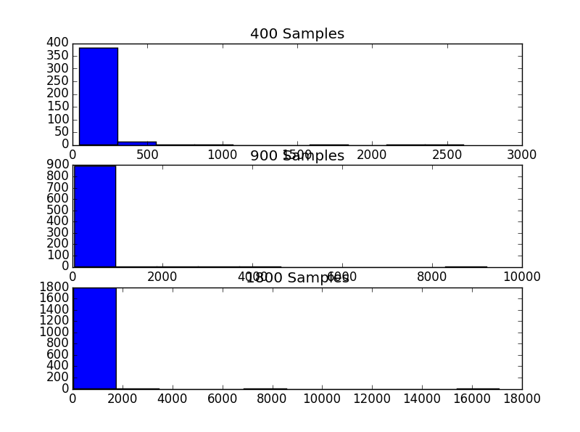

>>> runfile('C:/Users/S

neha/Desktop/PYTHON/q2b.py', wdir='C:/Users/Sneha/Desktop/PYTHON')

average packet size of 400 samples 130.989495856

average packet size of 900 samples 147.795416311

average packet size of 1800 samples 143.092157964

>>>

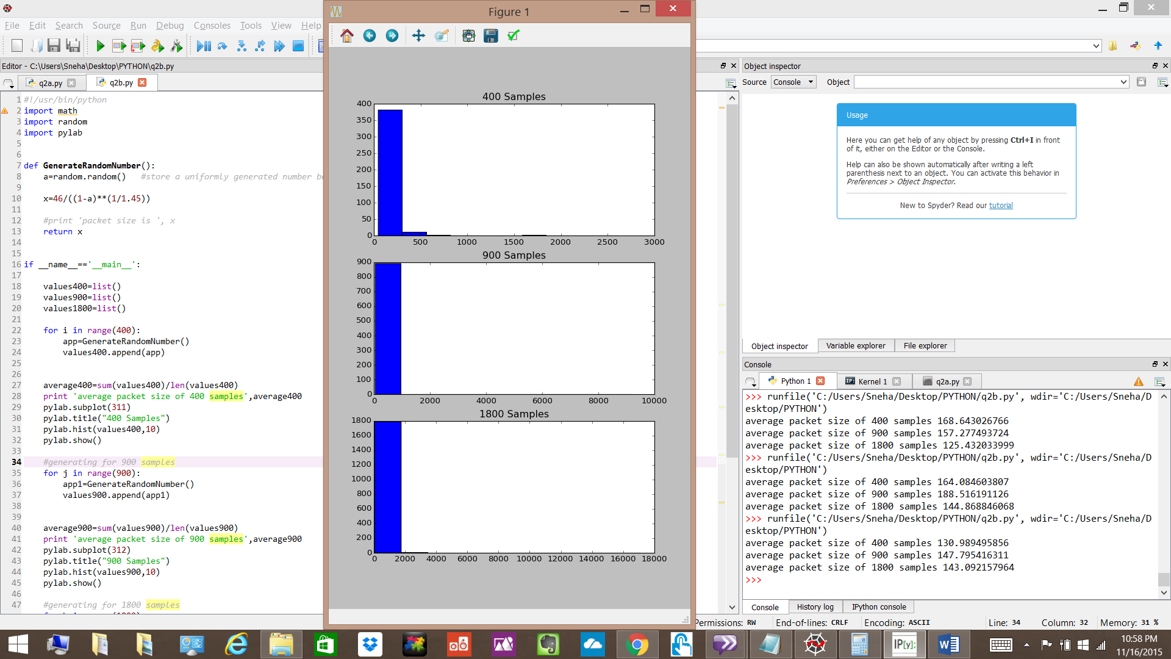

Q2c

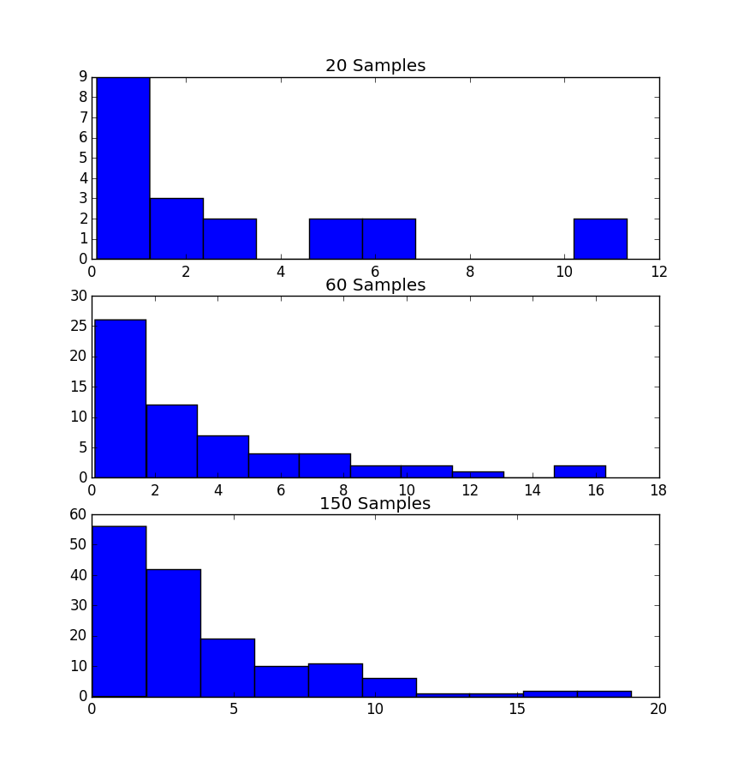

>>> runfile('C:/Users/Sneha/Desktop/PYTHON/q2c.py', wdir='C:/Users/Sneha/Desktop/PYTHON')

x is 2.53230128696

x is 2.70642872028

x is 0.292292955862

x is 0.865801759685

x is 11.3257214394

x is 0.607028441758

x is 0.271001071223

x is 0.197600453572

x is 0.146569508378

x is 0.646782803333

x is 5.54960179437

x is 6.0395291805

x is 0.112062101907

x is 1.35260610244

x is 0.864525337269

x is 1.87234626771

x is 1.43611968413

x is 6.28181929795

x is 10.5592904655

x is 4.62861953972

mean of 20 samples 2.9144024106

variance of 20 samples 11.0852939829

skewness of 20 samples 1.33411515749

x is 1.86618699722

x is 4.37457786585

x is 2.73378782954

x is 1.37910841659

x is 1.70567841074

x is 5.75200070219

x is 4.83946685365

x is 1.45430549856

x is 16.2954471125

x is 0.311575485684

x is 5.16272494776

x is 1.54225251683

x is 0.821178516589

x is 0.576416915117

x is 7.26598162657

x is 1.0931715149

x is 1.73031572281

x is 7.426787547

x is 0.116071262503

x is 0.399138183301

x is 2.43889233027

x is 5.36869911305

x is 1.14215019788

x is 2.10779967233

x is 1.28085398027

x is 0.110376087511

x is 2.43919870009

x is 3.80627719014

x is 1.44553048097

x is 9.43486121847

x is 2.70114739236

x is 0.709616025

x is 3.95224003492

x is 1.0334404627

x is 1.69041609812

x is 10.5509144217

x is 7.22278748707

x is 0.305126150945

x is 8.28508871733

x is 0.3697193538

x is 1.91811812419

x is 2.3524648394

x is 11.7206523415

x is 0.767196461522

x is 0.255205640354

x is 3.78014653357

x is 1.42735936945

x is 3.83002946196

x is 0.752314826332

x is 0.193856690752

x is 5.84887371063

x is 2.52073463138

x is 2.46377154668

x is 15.9265929493

x is 0.160361768371

x is 2.89535455766

x is 3.43006181719

x is 10.810698528

x is 6.66046199439

x is 0.168942361716

mean of 60 samples 3.51874178659

variance of 60 samples 13.8768803226

skewness of 60 samples 1.68684069167

x is 5.05706357049

x is 0.564452760284

x is 9.15587225091

x is 1.88566696721

x is 7.82743773827

x is 11.3258163529

x is 4.19594247917

x is 6.24417060269

x is 4.97628657898

x is 2.31637212178

x is 0.180404241965

x is 4.64927966267

x is 0.617818876752

x is 7.98934524764

x is 7.03001360418

x is 0.876119153366

x is 0.506858369283

x is 3.01381990763

x is 1.69438930682

x is 16.3331593585

x is 1.84096523487

x is 1.76936695942

x is 2.24814988728

x is 6.58260758155

x is 3.39256626079

x is 1.28671158373

x is 0.505409751936

x is 0.501119121361

x is 4.57940075361

x is 4.47530080329

x is 1.51005043244

x is 0.433774707643

x is 4.11824121309

x is 2.20683183365

x is 0.30300846679

x is 2.21398805344

x is 2.65316308218

x is 5.64942728715

x is 4.5503478462

x is 1.32505914504

x is 4.09746345107

x is 4.31345279821

x is 4.97035915338

x is 5.52242461762

x is 2.92933888152

x is 6.87570975802

x is 1.07449891645

x is 2.82886727276

x is 1.04065096299

x is 0.634950831003

x is 1.5050330615

x is 0.0281691183902

x is 2.09207303849

x is 2.91645013935

x is 2.51999167972

x is 3.52101486646

x is 6.50777692779

x is 6.2237336984

x is 4.18580018481

x is 1.10231225454

x is 2.35674494171

x is 0.606293399155

x is 0.792533395509

x is 8.40540039695

x is 0.533951051414

x is 2.13557974709

x is 0.576155662692

x is 0.563904389513

x is 0.0956062381351

x is 2.71581774786

x is 14.8180262842

x is 2.49424585949

x is 18.532548804

x is 4.1569224809

x is 10.9919215075

x is 3.2552950247

x is 2.06242467164

x is 1.73754065406

x is 3.03739483361

x is 1.08014412052

x is 1.38359178315

x is 8.07489978699

x is 3.11252090908

x is 2.65827792148

x is 1.13375976472

x is 8.57984270987

x is 1.13438540028

x is 3.19650950888

x is 9.63378211481

x is 4.56525691163

x is 3.50048174856

x is 6.43872593282

x is 4.03265377254

x is 1.04514240142

x is 2.72367953496

x is 3.5983194777

x is 0.0836777712403

x is 1.23041894544

x is 3.16373573627

x is 11.8003905447

x is 0.123239368292

x is 2.66208993982

x is 0.95174838555

x is 15.9195825557

x is 4.45756415784

x is 1.60737432424

x is 1.48052243399

x is 0.280853168055

x is 2.87323943921

x is 9.75020247032

x is 0.381334460097

x is 1.22280735216

x is 10.1082407348

x is 5.35551705263

x is 2.22753024219

x is 2.56779962861

x is 3.24354442758

x is 0.562855061608

x is 7.73880032089

x is 9.26758798591

x is 2.92604254464

x is 1.30769865315

x is 1.92189211114

x is 3.68258862689

x is 0.190294401292

x is 1.68359571678

x is 3.57742621153

x is 8.37843423831

x is 0.0832396266295

x is 8.24217444821

x is 0.490206009011

x is 2.31872144858

x is 1.87462101361

x is 10.4685195622

x is 3.68903218206

x is 6.96910658018

x is 1.9800552366

x is 19.0297378494

x is 1.4578084224

x is 3.20540660268

x is 0.141839327944

x is 7.29731150208

x is 2.8567928105

x is 3.49574251267

x is 6.14158742723

x is 0.138938505375

x is 0.503514085634

x is 3.47604868272

x is 1.87004147094

x is 8.41656544053

mean of 150 samples 3.84074514278

variance of 150 samples 13.7580992192

skewness of 150 samples 1.77803624442